**How to map the Disc Station (DS) from ZEISS880 microscope**

You can store your data directly to your IEB P: drive or to Imaging facility DS I: drive

**How to map disc station**

* Log in to Windows
* Select **Computer** from the Start menu
* Select **Map network drive**
* Name the drive **as I:**
* Select from history or type:

**\\ds-ueb-if.asuch.cas.cz\home** (to connect imaging facility disc station)

**OR**

**\\ds.asuch.cas.cz\home** (to connect your IEB P: drive with 100 GB capacity)

* check checkbox → connect using different credentials
* Press **Finish** button
* log in as ASUCH user (your name and psswd)
* (or as an external user (user name: **ds-ueb-if\**your name and psswd)

**The Disc Station will be available as your new drive (I:) on microscope PC, you can save your data directly there.**

**Before leaving disconnect** the I: drive by right-mouse button on I: drive and select Disconnect

**How to reach your data at work**

* in ASUCH domain, map the Imaging Facility Disc Station on your PC analogically as above

**How to reach your data from home**

* connect by VPN to ASUCH domain and map Imaging facility disc station

**or from Windows computer out of ASUCH domain:**

* type web address <http://ds-ueb-if.ueb.cas.cz>
* log in
* 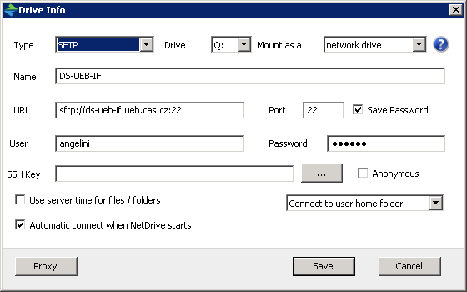choose left top icon
* in File Station work with your files

OR install Netdrive2 ([www.netdrive.net](http://www.netdrive.net)), configure as follows and connect imaging facility disc station as new drive

**From Mac:**

* map disc using Finder, select on top **Go -> Connect to Server**. Fill in path afp://ds-ueb-if.asuch.cas.cz/home and log in as in ASUCH domain. Enjoy!  **Help Katka l. 435**