5. 4. 21017

Plant growth-promoting bacteria from Arabian deserts as biofertilizers
Lukáš Synek

Heribert Hirt’s Lab, King Abdullah University of Science and Technology, Kingdom of Saudi Arabia

The rhizosphere, a narrow soil region around plant roots, consists of a variety of microorganisms that can potentially help plants to adapt to environmental conditions. Several bacterial strains isolated from desert plants colonize plants in lab conditions and improve plant resistance to various environmental stresses. The most efficient strain modulates the ethylene pathway to promote Arabidopsis growth and salt resistance.

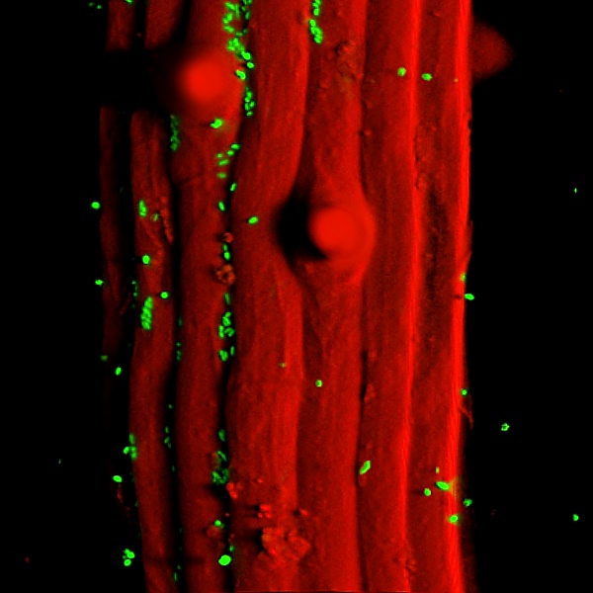

How we hunt for new bacteria in Arabian deserts, how is travelling around the Kingdom, how are local people and how is our living in the KAUST campus will follow after a coffee & dates break.

